
Module 3: History of Peer Support – Participant Handbook

Information from Slides 2
Homework to complete before Module 4 5
Reading: How Stigma Affects Us Both Individually and as a Collective of Peer Support Professionals by Moira Wheeler 5
Activity: Submit self-stigma response (approx. 15-20 minutes) 9

Information from Slides
Definitions for the first five terms are from the Government of Canada website.
Determinants of Health are a broad range of personal, social, economic and environmental factors that determine individual and population health.
Social Determinants of Health refer to a specific group of social and economic factors within the broader determinants of health. These factors relate to an individual's place in society, such as income, education, or employment. Experiences of discrimination, racism, and historical trauma are important social determinants of health for certain groups, such as Indigenous Peoples, LGBTQ2S+, and Black Canadians.
Health inequalities are differences in the health status of individuals and groups. These differences can be due to your genes and the choices you make. For example, whether you exercise or drink alcohol. However, the social determinants of health can also have an important influence on health. For example, Canadians with higher incomes are often healthier than those with lower incomes.
Health inequity refers to health inequalities that are unfair or unjust and modifiable. For example, Canadians who live in remote or northern regions do not have the same access to nutritious foods such as fruits and vegetables as other Canadians.
Health equity is the absence of unfair systems and policies that cause health inequalities. Health equity seeks to reduce inequalities and increase access to opportunities and conditions conducive to health for all.
Stigma is when someone sees you in a negative way because of your experiences with mental health and/or addiction.
Discrimination is when someone treats you in a negative way because of your experiences with mental health and/or addiction.
Self-stigma refers to the internalization of negative social stereotypes, which in turn impacts people’s sense of identity and leads to reduced self-esteem and diminished expectations. (MHCC 40)

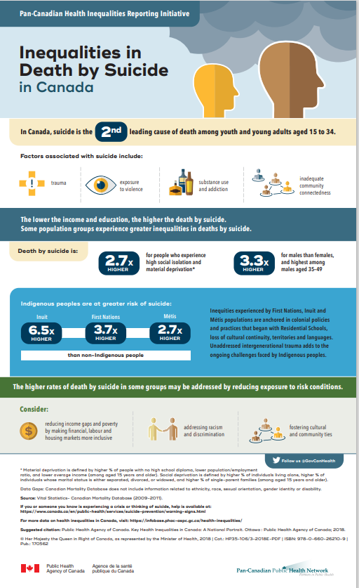https://www.canada.ca/en/public-health/services/publications/science-research-data/inequalities-death-suicide-canada-infographic.html
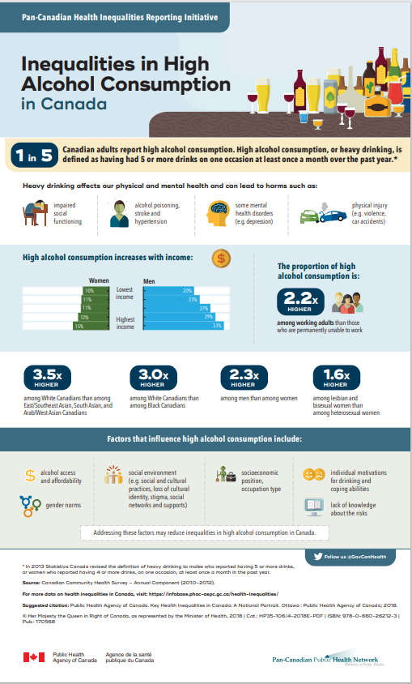https://www.canada.ca/en/public-health/services/publications/science-research-data/inequalities-high-alcohol-consumption-canada-infographic.html

Homework to complete before Module 4
This homework should be completed before Module 4. It should take approximately 30 minutes.
- Reading: Moira Wheeler’s “How Stigma Affects Us Both Individually and as a Collective of Peer Support Professionals.” Should take approx. 5-8 minutes.

- Activity: Submit self-stigma questions.

Reading: How Stigma Affects Us Both Individually and as a Collective of Peer Support Professionals by Moira Wheeler

How Stigma Affects Us both Individually and as a Collective of Peer Support Professionals
By Moira Wheeler

**The following is an excerpt from a book I am now writing in greater detail.**

As I begin to speak on this topic, I feel it is only fair to introduce myself so that you understand the experience I am speaking from.
My name is Moira, and I am declaring myself as a Person of Lived Experience of trauma from abuse and subsequent depression, anxiety and post-traumatic stress disorder (PTSD).

I have lived through 7 major hospitalizations, 5 at Provincial Hospitals and 2 at our Regional Hospital after the Provincial hospital was closed. This has covered a period from 1986 to 2014, age 26 to age 53. I am now 60 years of age. Several errors were made in both my diagnosis and treatment over this time.
During times of reasonable recovery, I sought to assist the Peer Movement in Ontario, as best I could. I served as a Board Member of our district’s Peer Initiative and later for a 6-year term on OPDI’s Board of Directors. I gave myself to this, and other volunteer endeavors over a total period of 26 years (from age 32 to age 58)

What Stigma Is
In my experience, stigma is a judgement, or series of judgments, made in a derogatory way to place others in a lesser than position. It is a form of power and control and a type of abuse.
(The Oxford dictionary further defines it as “in particular constituting or conveying a mark of disgrace.”)

How Stigma Has Affected Me
During my second hospitalization, when I was erroneously diagnosed with schizophrenia. I felt my Life was over. Life as I knew it certainly was. The year was 1990 and I was soon to turn 30. My marriage had ended, and I had entrusted my 18-month-old son to his father and his grandmother while I sought treatment. I did not know if I would see him and be able to care for him again.

The medication was harsh and had many serious side effects. The career opportunities I had studied for appeared to be over and I could barely recognize myself. There seemed so little left of who I had been. I felt stripped of all that had meaning to me, including a strong, clear, reasonably intelligent mind.
I expressed to my Aunt Theresa my feelings of grief and anger at the injustices I had witnessed against myself and others while in the Provincial Hospital. I was angry about the judgments placed upon those of us branded as “Mentally Ill.” I spoke of the further pain from judgments made by some family members, former friends, the community, and the system itself. I was left feeling as though there was truly nothing left for me in this Life.
I told my aunt about starting to get a bit better in the hospital and looking around me in utter amazement at the idea of treatment there, which often took the form of punishment. I thought, “How is anyone expected to get better under these conditions?” and with that thought came a deep passionate feeling that I must do something, anything to help to improve the system.
I was deeply angry at a system that would declare itself a “Healing System” while treating patients with mental-health experience as second class and further teaching and perpetuating stigmatic views about them.

I saw how these patients—myself included—then carried this shame out into the world, where we continued to be treated as lesser than, valueless, and of little consequence.
The systematic belittlement continued. After being discharged from the hospital in 1990, the most you could hope for was to be tolerated by your community, even by your own family, and you often re-entered society with little true hope for a Life of meaning.

My aunt had been a friend and a strong mentor to me from early childhood. She began by validating what I had shared. She had been a nurse and during her time in provincial hospitals had witnessed what I was talking about, and it hurt her to see it, as she understood how wrong it was.

She validated my feelings and confirmed that what I had seen had happened and was still happening.

She told me, “You are right to feel indignant and angry,” and then she continued, “But what will you do now with what you have experienced? How will you work to ensure that those who follow you will have it better?” I told her I didn’t know. And then she said, “Do not beat your head against the system; it will eat you up and spit you out. The only way is to find a better system. Build a better system and hold true to it until it is recognized and then safeguard it!”
I told her I didn’t know if any better system existed and she said, “Go out into Nature, stand and ask to find such a system and you will be led to it.” This practice had long been a part of our Spirituality, so I did. In Time, I found the Peer Initiatives and that has made all the difference because, in doing so, I found a direction, purpose and meaning to my Life again. To the best of my ability, I have given to the Peer Movement because I recognized both the need for it and its innate Value. The principles, the essence and the inclusion of this movement has saved many people and brought back Value to our Lives. Considering the degree of stigma we have had to overcome, the movement has been priceless.
In effect, stigma states, “You are lesser and therefore deserving or entitled to less.”

Stigma inflicted on those experiencing mental health challenges plays out as:
- Lesser or no health care
- Lesser or no income
- Little right to be listened to
- Little value in society
- Substandard homes to live in
- A cause for further mistreatment
- and on and on it goes
Stigma does deep and spiraling damage to those already suffering and struggling. This unkindness during a time of extreme vulnerability can compound suffering, and as such, stigma has the power to cause great and lasting damage, including heightening feelings of despair and suicidal ideations.

In this way, I see stigma as potentially murderous. Even if it does not result in the taking of a Life, at the very least, it takes from a person their sense of worth and their right to a legitimate place in the world. It takes from a person their right to be here. And it takes from a person the right to grieve the multitude of losses that we often face during and after experiencing declined mental health.
This lack of right to our grief results in keeping us unwell, because a person cannot fully heal without healthy expression. Perhaps the worst of it is that we begin to believe these judgements to the point of taking it on and judging ourselves and others similar to us accordingly.
In reading this you will likely realize the many ways you have been stigmatized and treated as lesser than others and this both hurts us and may anger us. If you are feeling this, please seek out Peer Support and any forms of therapy open to you. Pain, sorrow, and anger are all parts of the grieving process.
How Has Stigma Affected the Peer Support Movement?
When our very Lived experiences, our lessons, our ways of getting to a point of recovery and our wisdoms are seen as less valuable than textbook knowledge and therefore worthy of less pay - this is a form of stigma.
The Peer Movement has had to deal with this very form of stigma throughout the
History of the Movement. People who came before you had to fight this injustice and attempt to create a strong and beautiful movement. As a result of these efforts, there are accessible Peer Workers in hospitals, community organizations and throughout the Mental Health System.
The Peer Movement has faced stigma upon stigma and has faced it with strength, fortitude, endurance and - at its core - an innate and enduring kindness
Building a movement under these conditions (and even those that exist today) would have driven most other people crazy, and yet we are still here, and we keep fighting to create a better, more humane system.

That, in itself, says a great deal about who we are. So, stand proud wherever you stand and know this, most of us “old timers”, who slogged away trying to create a better, more humane system had a clear reason for fighting: we swore an oath to ourselves that those younger than us who had to enter the Mental Health System would do so under better conditions. We wanted to make sure there were Mental Health options that were a little kinder, a little more comprehensive of the needs of the entire body, a little more understanding and that would respect our worth as human beings. To a large degree we did it for you who follow us “for you are a child of the Universe, no less than the trees and the stars, you have a right to be here.” (Borrowed from the Desiderata)

So hold the torch high, go forward and may your work be Blessed.

Sincerely and with great respect,

Moira

Activity: Submit self-stigma response (approx. 15-20 minutes)
Answer the following questions:
Do you recognize any examples of self-stigma within yourself?
If not, are there any examples of self-stigma you USED to experience or have seen in a peer?
Describe the experience and suggest one thing that might have helped to reduce this self-stigma.

Answering these questions should take approximately 15-20 minutes, but not all of this time has to be spent writing. Take time to reflect on your answers and write a few lines for each question.

Submit your response before the next synchronous session.

Please e-mail your response to [NAME] at [name@peerworks.ca] with the subject line “Your Name Self-stigma.” e.g. “Allyson Self-stigma.”
You can send your response in the body of the email or attach your response as a Word document and name it “Your Name Self-stigma.” E.g. “Allyson Self-stigma.doc”

